**Describing a process**

**Exercise 5.**

Click [***here***](https://drive.google.com/file/d/1QBkg5N56-UDoM6TQd6tnrnAj5xg2hVP3/view?usp=sharing)to listen 10.7.

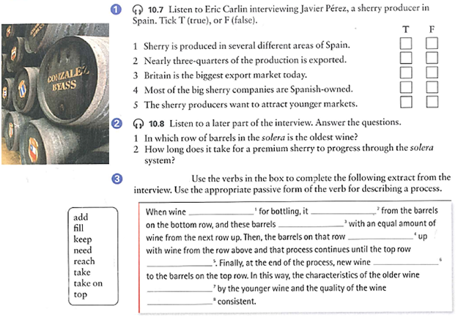Click [***here***](https://drive.google.com/file/d/1XAdFip5U4l-moc8kKkJhaHjqYC2qPDE3/view?usp=sharing) to listen 10.8.

**F**

**T**

**F**

**F**

**T**

**The oldest wine is In the barrels at the botton.**

**It takes 8 years or longer.**

**Is needed is taken**

**Are filled**

**Are topped**

**Is reached is added**

**Are taken on**

**Is kept**

**Exercise 7.**

**Active or passive?** Write the correct form of the verbs between brackets.

**Denim: from cotton to a pair of jeans.**

**1)**  Bales of carefully selected cotton ……arrive……… *(arrive)* at the denim mill. In the opening stage, baled cotton fibre ………is separated…… *(separate)*into small tufts. Different varieties of cotton can ……be blended…………… *(blend)* together to produce optimal yarn strength.

**2)** Next, the cotton ……………is turned…………………… *(turn)* into a web of fibres which then ……………goes………… *(go)* through a process known as carding where short fibres, sticks, leaves and any other dirt ……………are removed…… *(remove)*. The “cards” also ……convert……… *(convert)* the web into a rope-like form called sliver.

**3)** The drawing process …………produces… *(produce)* a single, uniform silver from six silvers. This silver ………is drawn………………………… *(draw)* out into a thinner yarn. Then, these ropes .are put… *(put)* on spinningmachines that ………twist………………………… *(twist)* and …………stretch……………………… *(stretch)* the fibres to make yarn.

**4)** Large balls of yarn, called ball warps, ………are dipped………… *(dip)* into an indigo mixture several times. Next, in the beaming process, the dyed rope ……………is separated…… *(separate)* into individual warp yarns which …… are …… then … coated…… *(coat)* in starchy substances to make the threads stronger and stiffer.

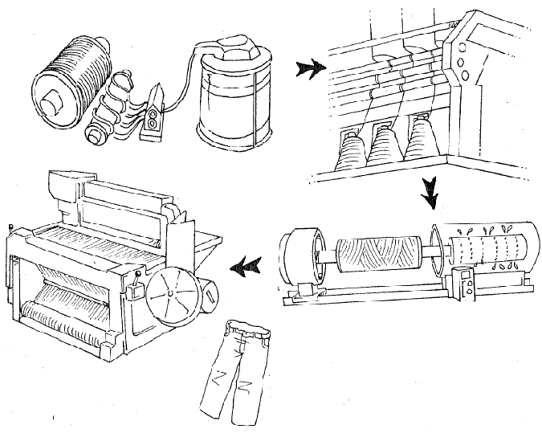**5)** The yarns …… are……… finally ……… woven/weaved… *(weave)*, interlacing the warp -long, vertical blue dyed threads- with the weft –shorter, horizontal white threads- on a large mechanical looms. The denim ………is……………… *(be)* ready for finishing, a term referring to a variety of treatments applied to the cloth like brushing, singeing – burning off stray fibres with a flame- and skewing –used to prevent it from twisting when it …is made…………………… *(make)* into clothing. The finished cloth …………is……… *(be)* now ready to …………be rolled…… *(roll)* and finally ………is sewn/sewed ………………… *(sew) for clothing manufacture.*

**Exercise 8.**

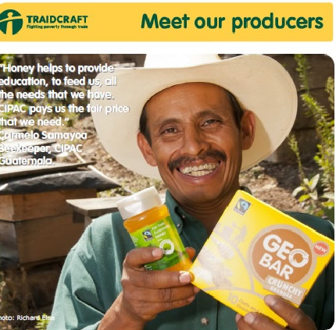****

**Video “TRAIDCRAFT”** Click [***here***](https://drive.google.com/file/d/1--acU2vtCM7RYTh1spdhPPu2nQlvCrYR/view?usp=sharing)

1) **Mention 3 developing countries and 3 developed countries**.

Developing: Argentina, Peru, Bolivia

Developed: USA, England, Spain

2) **Match each word with its definition:**

1. fair-b a. *Cultivated plants or agricultural produce, such as grain, vegetables, or fruit*

2. trade-d b. *Just; equitable.*

3. crop-a c. *bluish berries which can be eaten*.

4. blueberries-c d. *The business of buying and selling commodities; commerce*.

3) **Watch the video about Traidcraft and answer the following questions:**

a) Where are the developing countries mentioned situated?

Africa, South and South East Asia and South America.

b) Crops mentioned which are grown in these regions.

Coffe,tea,sugar,rice,flowers,bananas,pineaples and grapes

c) 3 problems the population in these regions have:

1) They often live in low grade housing /They don’t get a fair price when trading

2) They have limited access to clean water

3) They have little or no access to a good education.

d) How many honey producers belong to APICOOP?

There are about 300 honey producers.

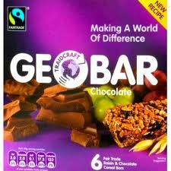e) How are Valdivia and Gatehead related through Traidcraft?

Traidcraft buys goods from Valdivia and Gatehead with a fair price.

f) Mention 3 ingredients in GEOBAR and their origin.

………………grapes…………..from ……south africa………………………

……………honey and …..from… APICOOP ,valdivia, chile…………….

………… blueberries ……..from…… APICOOP ,valdivia, chile ……….

g) What is the money from Geobar sales used to buy for?

Part of it is used for buying water pomps and school bags for children

4**) Complete the following sentences in PASSIVE VOICE**:

1) Honey ………………is produced…………………(produce) in Valdivia.

2) Traidcraft products ………are sold…………..(sell) in the UK.

3) Goods from the developing world …………are bought…………(buy) by Traidcraft.

4) Fairtrade ………was established……………..(establish) in 1992.

5) A fair price ……was paid…………(pay) for the products.

6) This crop ………is grown………..(grow) in Southeast Asia.